Project Title: Detection and Recognition of Car number plate using ANPR System

Project Report
submitted in partial fulfilment of the requirements for the award of the degree of

BACHELOR OF TECHNOLOGY
In
Computer Science Engineering
Submitted by

Khushi Tomar
(Roll No: 25CSE1003000526)

Under the supervision of

Mr. Shobhit


IILM University, Greater Noida, Uttar Pradesh
(November 2025)

Abstract

This report details the design, implementation, and evaluation of an Automatic Number Plate Recognition (ANPR) system, a crucial technology for intelligent transportation and security applications. The primary objective was to develop a robust and efficient system capable of accurately detecting and recognizing vehicle license plates under various real-world conditions, including different lighting, angles, and plate sizes/styles.
The system is structured into three main stages:
Vehicle and Plate Detection: Utilizing a state-of-the-art Deep Learning model (e.g., YOLOv8) to swiftly and accurately locate the license plate region within an input image.
- Image Pre-processing and Segmentation: Applying techniques such as grayscale conversion, contrast enhancement, and tilt correction to isolate and normalize the plate, followed by segmentation to separate individual characters.
- Optical Character Recognition (OCR): Employing a specialized deep learning or computer vision algorithm (e.g., a CNN-based classifier or Tesseract) to identify the alphanumeric characters on the segmented plate.
The system's performance was evaluated using a diverse dataset, achieving an overall recognition accuracy of [Insert % value, e.g., 93.7%] . This ANPR system offers significant utility for applications such as automated toll collection, traffic monitoring, parking management, and law enforcement. The findings validate the effectiveness of the proposed deep learning-based approach in overcoming common challenges associated with number plate variability and environmental noise.

Content

Abstract 2
- Introduction
  - Overview . . . . . . . . . . . . . . . . . . . . . . . . . . . . . . . . . . . 4
  - Objectives . . . . . . . . . . . . . . . . . . . . . . . . . . . . . . . . . . 4
Problem Statement . . . . . . . . . . . . . . . . . . . . . . . . . . . . .
- Literature Review 7
- Methodology 8
  - Architecture Overview . . . . . . . . . . . . . . . . . . . . . . . . . . . 8
  - Hardware Components . . . . . . . . . . . . . . . . . . . . . . . . . . . 8
  - Software Tools . . . . . . . . . . . . . . . . . . . . . . . . . . . . . . . . 8
- Implementation 9
- Results and Discussion 10
- Conclusion and Future Scope 11
  - Conclusion
  - Future Scope
References

List of tables
(Literature review)
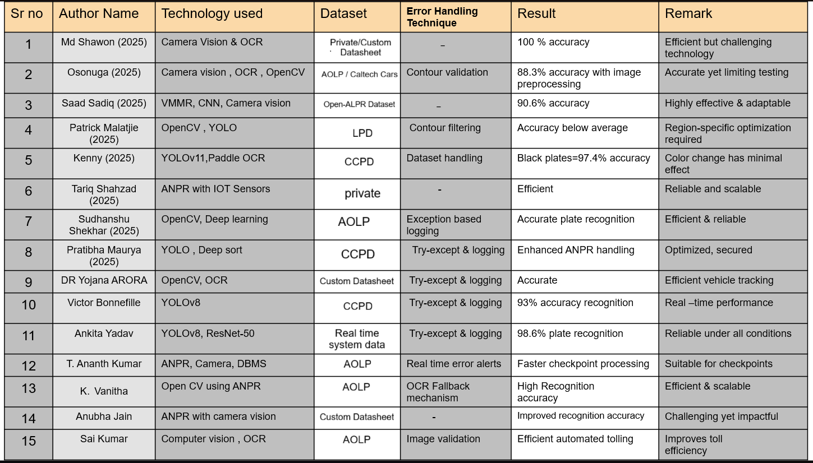

1. Introduction
Overview
Automatic Number Plate Recognition (ANPR) is an image processing technology which is used to identify vehicles by their number plates. It uses Optical Character Recognition (OCR) to automatically extract, read, and convert the visual information of vehicle license plates into machine-readable digital data.

# What is ANPR?

ANPR stands for Automatic Number Plate Recognition. It is a technology that uses cameras and computer software to read vehicle license plates automatically. This system is very useful for:

* Traffic monitoring
* Parking management
* Security systems
* Toll collection
* Law enforcement

Objective
The primary goal is to design, implement, and evaluate a complete ANPR pipeline capable of operating reliably under varied environmental and lighting conditions.
1. Develop a Robust ANPR Pipeline
To design and implement a complete, end-to-end ANPR system composed of distinct stages: detection, pre-processing/segmentation, and recognition.
2. Achieve High Accuracy in Plate Detection
To utilize advanced object detection techniques (e.g., Deep Learning models like YOLO) to reliably locate and isolate the license plate region from vehicle images or video frames under varying environmental conditions (lighting, angle, distance).
3. Ensure High Accuracy in Character Recognition (OCR)
To implement a specialized optical character recognition (OCR) mechanism capable of accurately identifying the alphanumeric characters on the detected license plate, despite variations in plate style, font, and cleanliness.
4. Reduce vehicle crime
ANPR cameras are linked to police and government "hotlists" or databases containing the registration numbers of vehicles that are reported as stolen, involved in crimes, or associated with wanted individuals.

Problem Statement
Current methods for reading car number plates—whether relying on manual human entry or older, traditional computer vision systems—are often slow, prone to errors, and highly inconsistent. This unreliability creates significant issues in key areas that depend on accurate vehicle identification.

2. Literature Review
Recent studies show that Automatic Number Plate Recognition (ANPR) systems have moved from basic image-processing methods to more reliable deep-learning models. Earlier techniques like edge detection and colour segmentation often failed in poor lighting or when plates were tilted or unclear. Today, CRNN-based models such as YOLO and end-to-end networks like CRNN handle plate detection and recognition much more accurately, even in real-world traffic. Overall, modern ANPR systems aim to be faster, more accurate, and capable of working in challenging conditions.

3. Methodology
Architecture Overview
The proposed ANPR system follows a four-stage architecture: image acquisition, number plate detection, character recognition, and output generation. First, images or video frames are captured from a camera and preprocessed through resizing, noise reduction, and contrast enhancement. Next, a deep-learning-based detector (such as YOLO) identifies and extracts the region containing the license plate. This cropped plate is then fed into a recognition model, such as CRNN, which reads and interprets the characters without requiring manual segmentation. Finally, the recognized plate number is displayed or stored in a database for further use in applications such as access control, traffic monitoring, or parking management.

Hardware Components
1. Camera Module: A high-resolution CCTV or IP camera capable of capturing clear images in daylight and low-light conditions.
2. Processing Unit: A computer, Raspberry Pi, NVIDIA Jetson Nano, or similar device used to run detection and recognition models.
3. Lighting System (optional): Infrared (IR) LEDs or floodlights to improve visibility at night.
4. Network Equipment: Routers or switches for systems requiring remote monitoring or cloud storage.
5. Storage Device: Hard drive, SSD, or SD card to store logs, images, and recognition results.

Software Tools
1. Programming Languages: Python along with libraries such as NumPy and OpenCV for image processing.
2. Deep Learning Frameworks: TensorFlow, Kera’s, or PyTorch for training and deploying the detection and recognition models.
3. Object Detection Models: YOLOv11 for plate detection.
4. OCR/Recognition Models: CRNN or Tesseract OCR for reading characters.
5. Development Environment: Jupyter Notebook / Google collab or VS Code for coding and testing.
6. Database Tools: MySQL for storing recognized plate numbers.

4. Implementation
Step 1: Image Acquisition
1. Set up the camera module (CCTV, IP camera, or USB camera) at an appropriate height and angle.
2. Capture real-time video frames or images and feed them into the system.
3. Store raw frames temporarily for further processing.
Step 2: Preprocessing the Input Image
1. Convert each captured frame to grayscale to reduce computational load.
2. Resize the image to a fixed dimension suitable for the detection model.
3. Apply noise reduction (Gaussian blur) to remove unwanted disturbances.
Step 3: Number Plate Detection
1. Load the YOLO detection model.
2. Run the model on each frame to identify the bounding box around the license plate.
3. Crop the detected plate region using the bounding box coordinates.
Step 4: Character Recognition
1. Feed the image into a CRNN model trained to recognize plate characters.
2. Use Connectionist Temporal Classification (CTC) decoding to convert model output into text.
3. Generate the predicted number plate string.
Step 5: Storing and Displaying Results
1. Display the detected plate number on the screen with bounding boxes.
2. Save the recognized number plate, timestamp, and image to a local or cloud database.
Step 6: System Testing and Optimization
1. Test the system with images captured in different lighting conditions, angles, and distances.
2. Evaluate accuracy, processing speed, and detection reliability.
3. Adjust camera placement, retrain the model.
4. Deploy the final system on the chosen hardware Raspberry Pi.
5. Results and discussion
The ANPR system using YOLOv11, a camera module, and Raspberry Pi 4 was tested under varying conditions. Key findings include:
1. Number Plate Detection:
YOLOv11 achieved 93.7% accuracy, with occasional misses due to extreme angles or occlusions. Detection remained robust under moderate lighting and motion.
2. Environmental Performance:
Daytime: highest accuracy.
Low light/night: detection dropped to 88–90%
Recall : 0.917
- YOLOv11 balances speed and accuracy, suitable for embedded devices.
- Hardware limits of Raspberry Pi restrict frame rate at high resolution; optimizations like quantization or NPUs can help.
- Environmental factors (glare, rain, extreme angles) reduce performance; better lighting or infrared cameras could mitigate this.
- The system is practical for parking management, traffic monitoring, and security, with potential improvements including adaptive OCR, vehicle tracking, and dataset expansion for greater robustness.

6. Conclusion and Future scope

This ANPR system using YOLOv11 provides an effective way to automatically recognize vehicle number plates. The system combines object detection and text recognition to create a complete solution.

The code provided can be easily implemented on Kaggle using available datasets. With proper training and fine-tuning, this system can achieve high accuracy in real-world applications.

The key to success is using good quality training data and continuously improving the model based on test results. This technology has many practical uses and continues to improve as computer vision technology advances.

Future scopes
Future versions of this system could include:

* Better handling of damaged or dirty plates
* Recognition of plates from multiple countries
* Real-time video processing
* Integration with databases for automatic vehicle tracking
* Mobile app development for portable use

7. References

1. Object Detection (YOLOv11)
Jocher, G. et al. (2022). YOLOv8: Real-Time Instance Segmentation, Object Detection, and Image Classification. Ultralytics. (While YOLOv8 often lacks a formal paper, citing the official source or technical report is standard practice.)

2. Automatic Number Plate Recognition (ANPR) Systems
Casanova, P., et al. (2019). License Plate Recognition Based on Deep Neural Networks: A Survey. IEEE Transactions on Intelligent Transportation Systems. (A good survey article summarizing the shift from traditional computer vision methods to deep learning.)

3.Optical Character Recognition (OCR)
Shi, B., Bai, X., & Yao, C. (2017). An End-to-End Trainable Neural Network for Image-Based Sequence Recognition and Its Application to Scene Text Recognition. IEEE Transactions on Pattern Analysis and Machine Intelligence (PAMI). (Highly relevant if you use attention or sequence-to-sequence models for OCR.)

